
COMPUTER APPLICATION TECHNOLOGY

2024
ABSTRACT
The current situation is that some areas primarily rural provinces have a percentage of waste collected below 60 percent which is poor.
PRACTICAL ASSESSMENT TASK
Name : Mbasa Batyi
GRADE : 12 M
District : CHRIS HANI DISTRICT
teacher : MR Muza
task : PHASE 3: REPORT
Sector : waste management
focus job : WASTE reduction sepecialist]

QUEEN’S COLLGE BOYS’ HIGH | mbatyi@queenscollege.co.za

Table of Contents

TABLE OF FIGURES ii
INTRODUTION 1
DICUSSION AND ANALYSIS 3
Waste Reduction Specialist. 3
How to become a waste reduction specialist? 3
Universities that offer studies to become a waste reduction specialist. 3
University of Cape Town 3
Stellenbosch University 4
University of Johannesburg 4
Differentiation between a Waste Reduction Specialist and Recycling Coordinator. 4
The current problem. 6
Possible solution of the current problem. 6
FINDINGS 7
CONCLUSION 14
BIBILOGRAPHY 15
APPENDICES 17

TABLE OF FIGURES

Figure 1 : Two Waste Reduction Specialists 4
Figure 2 : UCT campus 4
Figure 3 : Stellenbosch University campus 4
Figure 4 : University of Johannesburg campus 5
Figure 5 : Recycling image from the internet 5
Figure 6 : Waste Reduction Specialist at work 5
Figure 7 : Rubbish within the streets of South Africa 6
Figure 8 : Are you aware of a Waste Reduction Specialist? 8
Figure 9 : Universities with a recycling system implemented. 9
Figure 10 : Percentages of the duties of a Waste Reduction Specialist. 9
Figure 11 : Do Waste Reduction Specialists implements systems to reduce waste. 10
Figure 12 : Scale of the level of assistance a Reduction Specialist Requires 10
Figure 13 : Estimation of the annual gross salary of a Waste Reduction Specialist. 11
Figure 14 : Query for recycling centres 11
Figure 15 : Query for the average estimated annual salary 11
Figure 16 : Query for the amounts above the correct annual pay check and estimated hour salary 12
Figure 17 : Query for people who choose UCT with a rate of below 5 12
Figure 18 : Report for the analysis of the information derived from the respondents. 12

Table 1 : Duties of a Waste Reduction Specialist 7

INTRODUTION
This report is about the career of a Waste Reduction Specialist on how they influence lives and as well as how efficient are their methods on affecting lives. The research was carried out in order to learn more about alternate waste treatment techniques, such as material recovery facilities and the diversion of organic waste for composting. In addition to the previously mentioned reasons for not disposing of waste in landfills, environmental sustainability also helps the environment.
The objective of the research is to expand and inform those who would like to help individuals who are most affected by the current crisis by providing assistance with any environmental management — including waste disposal, recycling, and environmental remediation — in the Chris Hani District Centre in Queenstown.
The focus being fostering solidarity by expanding the networks and relationships allied organizations such as the International Alliance of Waste Pickers, the #BreakFreeFromPlastic movement, and climate justice organizations. Whether collaborating with waste pickers, fostering national alliances, or working with different sectors impacted by the effects of climate change, building strong networks, which is key to maximizing local impact, reaching national bodies, and increasing community engagement and public support for zero waste in order to ultimately create systemic change. ((ANC), 2022)
Recycling plays a crucial role in reducing greenhouse gas emissions by minimizing the need for new production processes. When we recycle materials like paper, glass, and plastic, it means that there is less demand for manufacturing these items from scratch. This leads to significant energy savings because collecting and using recycled materials may require less energy than producing goods from raw materials. For example, when we recycle paper instead of making it from wood pulp, we save trees and reduce the amount of energy needed to cut down trees and process them into paper. (Jam, 2023)
By reducing the need for new production processes through recycling, we can conserve natural resources such as water, minerals, timber, and energy. This conservation helps maintain the quality of our environment and energy by preventing overexploitation of these resources.
The effectiveness of recycling—indeed, its ultimate worth over time—will not be determined by the amount of landfill space avoided, but rather by whether recycling makes financial sense. Government and business must not only reinvent themselves but also their relationship in order to increase demand for recycled materials. This is particularly important when it comes to economic issues that neither party can resolve on its own. (Biddle, 2021)
This report will cover the following topics in its body: What constitutes a Waste Reduction Specialist, what courses must be taken to fulfil the requirements to work as one, and which universities offer waste management degrees. By differentiating between the two positions, this report will also erase widespread misunderstandings about Waste Reduction Specialists and Recycling Coordinators. More importantly, it will highlight the issues that the nation's poorest regions are currently facing and offer potential solutions.

DICUSSION AND ANALYSIS

Waste Reduction Specialist.
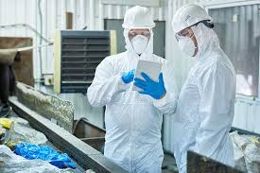
A professional who works to reduce waste and improve sustainability practices in communities or organizations is known as a waste reduction specialist. They carry out checks, examine waste generation patterns, and create plans to cut waste and enhance recycling and reuse. They are responsible for putting waste reduction plans into action, teaching stakeholders about sustainable practices, and making sure waste management laws are followed. They try to improve waste management systems and encourage environmental responsibility by monitoring waste data and investigating innovative technologies. In the end, a waste reduction specialist assists businesses in reaching their sustainability objectives and minimizing their environmental effect.
Figure 1 : Two Waste Reduction Specialists

How to become a waste reduction specialist?
Getting the necessary education is the first step towards becoming a Waste Reduction Specialist. It is necessary to have a bachelor's degree in environmental science, sustainability, or a similar field; however, you can also improve your credentials with advanced degrees or specialized coursework. In order to obtain real-world experience and expand your professional network, look for internships or entry-level jobs in the waste management or sustainability industries. It will also be crucial for this position to develop critical abilities like project management, analytical thinking, and effective communication.

Universities that offer studies to become a waste reduction specialist.

University of Cape Town
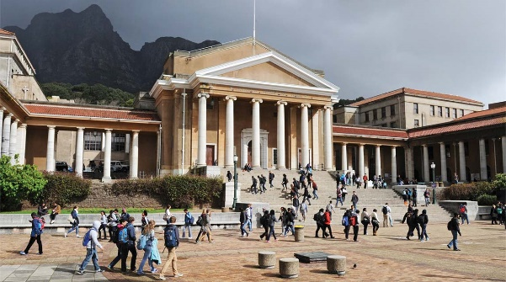
A number of universities highlight on environmental science, sustainability, and waste management in their programs and courses that are pertinent to becoming a Waste Reduction Specialist. Through its Department of Environmental and Geographical Science, the University of Cape Town (UCT) offers a variety of programs, one of which is a Master of Environmental Management that addresses sustainability and waste management issues. Because of UCT's focus on research and real-world applications, students graduate with the knowledge and abilities necessary to create and carry out successful waste reduction plans. UCT prospectus.pdf
Figure 2 : UCT campus

Stellenbosch University

Similar to this, the Centre for Environmental Management at Stellenbosch University offers a Master's in Environmental Management with an emphasis on waste management, environmental policy, and sustainable practices. The curriculum places a significant emphasis on both theoretical knowledge and real-world experience in order to prepare students for careers in waste management and environmental consulting. Furthermore, the University of the Witwatersrand (Wits) provides an engineering viewpoint on waste reduction technologies and processes through waste management courses offered under its School of Chemical and Metallurgical Engineering. Stellenbosch University prospectus.pdf
Figure 3 : Stellenbosch University campus

University of Johannesburg
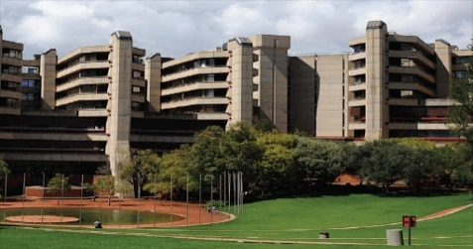
Related courses are offered at the University of Johannesburg's Department of Environmental Management. Its curriculum includes a strong emphasis on waste management techniques, environmental impact assessment, and sustainable development, equipping students for jobs in environmental consulting and waste reduction. All of these schools provide a thorough education that gives aspiring Waste Reduction Specialists the expertise they need to successfully handle waste management issues. University of Johannesburg propectus.pdf
Figure 4 : University of Johannesburg campus

Differentiation between a Waste Reduction Specialist and Recycling Coordinator.
Although both a Recycling Coordinator and a Waste Reduction Specialist strive to enhance waste management, their responsibilities and areas of emphasis are very different.
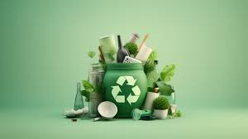
The main goal of a Waste Reduction Specialist is to reduce the total amount of waste generated by different industries. In order to find opportunities for reduction, they must analyse waste streams, develop and implement waste minimization strategies, and encourage sustainable practices within communities or organizations. This position frequently entails a wider range of activities, such as the creation of policies, programs for composting, and source reduction, all of which are intended to reduce the amount of waste generated. In order to achieve long-term sustainability, the specialist aims to incorporate waste reduction strategies into organizational practices and public behaviour.
Figure 5 : Recycling image from the internet

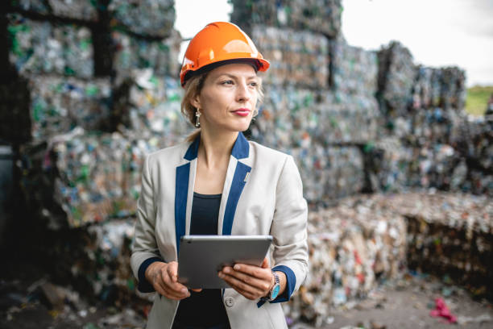
A Recycling Coordinator, on the other hand, is primarily concerned with the administration and improvement of recycling initiatives. Their responsibilities entail supervising the gathering, classification, and handling of recyclable items to guarantee their appropriate recycling instead of disposal in landfills. They are responsible for developing and overseeing recycling programs, informing the public and staff about recycling practices, and making sure that regional recycling laws are followed. Recycling is an important component of waste management, but a waste reduction specialist addresses many other aspects of the larger goals of waste reduction. Recycling Coordinators are usually more focused on the day-to-day operations of recycling programs, while trash Reduction Specialists approach sustainability and trash management more strategically.
Figure 6 : Waste Reduction Specialist at work

The current problem.
Locally problem
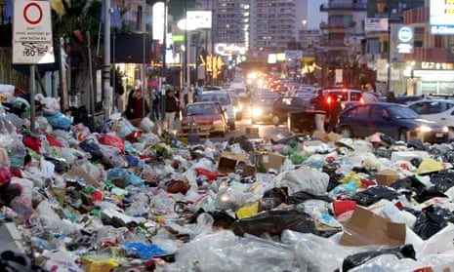
Approximately 70 to slightly over 90 percent of homes in urban areas currently have waste collection services available to them. The informal settlements presented difficulties. The proportion of collected rubbish was less than sixty percent in the provinces that are predominantly rural. Waste collection was somewhat less than 40% in typical regions because of the limited impact of municipalities. The average level of access to waste collection services across the country has remained largely unchanged over time, hovering around 70%. Due to widespread under-pricing of trash management, which meant that businesses and consumers were not completely aware of the costs of rubbish management, waste disposal was preferred over other solutions. ((ANC), 2022)
Figure 7 : Rubbish within the streets of South Africa

Possible solution of the current problem.
It is essential to implement targeted improvements and policy changes in order to address these challenges. To improve coverage and effectiveness, first boost investments in waste management services and infrastructure in rural and informal settlement areas. Boost recycling and waste collection rates in underserved areas by strengthening municipal capacities and offering incentives. Secondly, tackle the problem of under-pricing by modifying or introducing pricing structures that more accurately represent the actual expenses associated with waste management. This can entail putting in place tiered pricing structures that promote recycling and waste minimization. In addition, start public awareness campaigns to inform consumers and businesses about the environmental and economic effects of waste management. Waste management services can be made more sustainable and equitable across various regions by implementing these strategies.

FINDINGS
Figure 8 : Are you aware of a Waste Reduction Specialist?
It is a horizontal bar graph derived from the information collected from the survey that was issued out to the public, this bar graph shows how many people responded and from that total number being 63. It was split into responses of “Yes” and “No” to the question on the title of the graph being “Are you aware of a Waste Reduction Specialist”. This shows that about approximately 50% of people who answered the survey they do not know about the Waste Reduction Specialist and the difference are aware of Waste Reduction Specialists.

Figure 9 : Universities with a recycling system implemented.
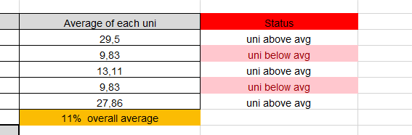
It is a bar graph with a line graph, the figure gives the reader insight on the numbers of each University that might be considered to have a recycling system implemented by a Waste Reduction Specialist. The Line Graph is a shows the average of each university obtained number against the other universities and against the overall average which is 11%.

Figure 10 : Percentages of the duties of a Waste Reduction Specialist.
It is a pie chart; this figure gives the reader insight on the percentages of the duties of a Waste Reduction Specialist chosen by the respondents based on their knowledge.
Duties of a Waste Reduction Specialist:
Duties | Percentages
Ensuring compliance with environmental regulations. | 34%
Responsible for anything that is waste related on the vessel. | 5%
Identifying opportunities for waste reduction and recycling.  13%. | 13%
Assessing waste streams. | 35%
All of the above | 12%
Table 1 : Duties of a Waste Reduction Specialist
Figure 11 : Do Waste Reduction Specialists implements systems to reduce waste.
It is a vertical bar graph, the figure shows the number of the total respondents (65) and as well as the number of the respondents that chose “Yes”/ “No” to the question on the title of the graph being, “Do Waste Reduction Specialists implement systems to reduce waste?”. This the reader an insight that the majority of the respondents are aware of a Waste Reduction Specialist.
Figure 12 : Scale of the level of assistance a Reduction Specialist Requires
It is a line graph this graph gives the readers insight on the numerical values derived from the survey that was issued out. These numbers show the sum of each level chosen by the respondents. The levels being 1 to 5 the level of assistance, starting from “No assistance” to “has huge assistance”. What was derived from this question from the respondents is that since a Waste Reduction Specialist might have loads of duties to complete the understood that a Waste Reduction Specialist will require great amounts of assistance at completing their duties.

Figure 13 : Estimation of the annual gross salary of a Waste Reduction Specialist.
It is a 3D bar graph, this above figure gives the reader insight to the estimations of the annual gross salary of a Waste Reduction Specialist made by the respondents, the lowest (R 28 033,00) and highest (R 446 408,00) estimation is compared to the correct annual base amount (R 334 547,00) earned by a Waste Reduction Specialist.

Figure 8 : Query for recycling centres
It is a query designed to show the respondents who know 5 or more recycling centres.

Figure 8: Query for the average estimated annual salary
It is a query design to show the respondents name and surname with their average estimated annual pay check amount which chose Stellenbosch University as the Institution where you can get a Waste Reduction Specialist degree.

Figure 9 : Query for the amounts above the correct annual pay check and estimated hour,salary
It is a query designed to show the respondents Name, Institution of their choice and as well as the Estimated Annual Gross Pay Check which are below the correct annual gross pay check and as well as the estimated hour salary.

Figure 10: Query for people who choose UCT with a rate of below five
It is a query designed to show the respondents who choose UCT with a rate below 5.
Figure 11: Report for the analysis of the information derived from the respondents.
It is a report designed to show all the fields of the Respondents Table grouped by the Institution where you can obtain a Waste Reduction Specialist Degree with calculations in the footer which show the number of respondents that chosen Institution, the highest estimated annual gross pay check and the lowest annual gross pay check

Figure 8 : Are you aware of a Waste Reduction Specialist?

Figure 9 : Universities with a recycling system implemented.

Figure 10 : Percentages of the duties of a Waste Reduction Specialist.

Figure 11 : Do Waste Reduction Specialists implements systems to reduce waste.

Figure 12 : Scale of the level of assistance a Reduction Specialist Requires

Figure 13 : Estimation of the annual gross salary of a Waste Reduction Specialist.
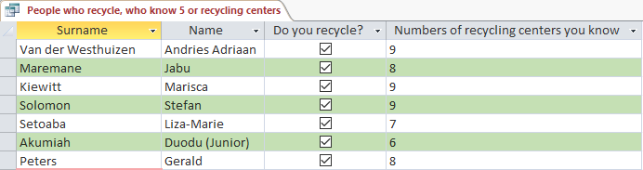
Figure 14 : Query for recycling centres
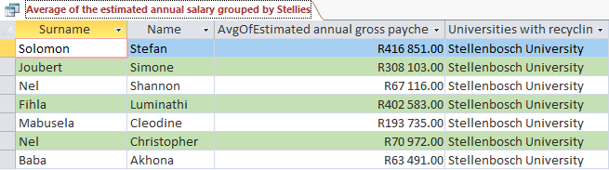
Figure 15 : Query for the average estimated annual salary
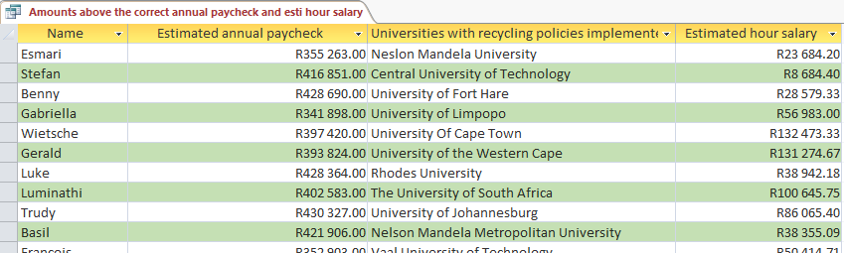
Figure 16 : Query for the amounts above the correct annual pay check and estimated hour salary
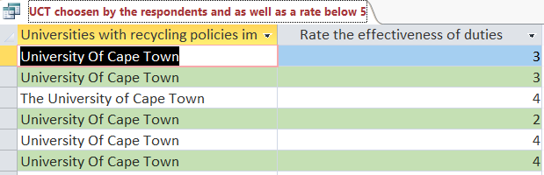
Figure 17 : Query for people who choose UCT with a rate of below 5
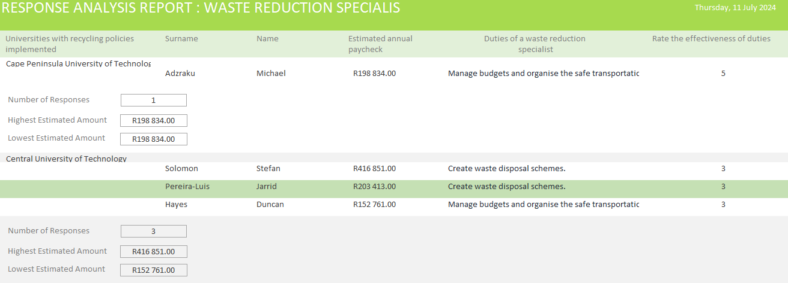
Figure 18 : Report for the analysis of the information derived from the respondents.

CONCLUSION
In summary, a Waste Reduction Specialist plays a critical part in solving today's urgent environmental issues. The present study has examined the many duties and important contributions of Waste Reduction Specialists, with a particular emphasis on their impact on environmental sustainability initiatives at the local and wider levels. The study emphasizes the critical role that waste treatment experts play in lowering landfill use and fostering environmental stewardship through a thorough analysis of waste treatment methods, such as material recovery facilities and organic waste diversion.
The report has well emphasized how effective waste treatment methods like composting and material recovery facilities allow Waste Reduction Specialists to make a positive difference in people's lives. In order to protect the environment, it also highlighted how crucial environmentally sustainable waste management techniques are. The discussion and analysis has also made it clear to those who would like to obtain a degree and go into the field of a Waste Reduction Specialist. Now to those who are interested in this line of work have more knowledge and understanding of what is expected of them and as well as the types of duties the might have to complete.
The report has also clearly painted a picture of how and which Universities that may offer the degree of becoming a Waste Reduction Specialist with the aid of University prospectus being provided.
The results highlight how efficient recycling and waste management contribute to the financial sustainability of sustainable practices in addition to protecting the environment and lowering greenhouse gas emissions.
The ultimate goal of this research is to provide understanding and remedies for the problems encountered by areas with limited resources, like Queenstown's Chris Hani District Centre. There is hope for significant advancements in zero waste and systemic environmental transformation through networking and solidarity building. In order to create a more sustainable future for all communities, waste reduction measures must be continuously supported and developed.

BIBILOGRAPHY
(ANC), C. M. (2022, 02 18). Status of Waste Management in South Africa. Retrieved from Summary: https://pmg.org.za/committee-meeting/34368/
Biddle, D. (2021, 11 09). Recycling for Profit: The New Green Business Frontier. Retrieved from Harvard Business Review: https://hbr.org/1993/11/recycling-for-profit-the-new-green-business-frontier
Hedda. (2022, 03 24). Propects is part of JISC. Retrieved from Propects: https://www.prospects.ac.uk/job-profiles/waste-management-officer
Higa, V. (2023, 07 18). Environmental sustainability consulting for waste management strategies. Retrieved from https://utilitiesone.com/environmental-sustainability-consulting-for-waste-management-strategies
info@wasteplan.co.za. (2018, 10 22). Waste reduction VS Waste disposal and reducing your carbon footprint. Retrieved from Waste reduction VS Waste disposal and reducing your carbon footprint: https://www.wasteplan.co.za/waste-reduction-vs-waste-disposal-and-reducing-your-carbon-footprin
Jam, S. (2023, 06 05). Recycling: Defining Objectives, Evolution, and Environmental Benefits. Retrieved from Medium: https://medium.com/@sohrabjam/recycling-defining-objectives-evolution-and-environmental-benefits-b7ef1e9a729c
Jay N. Meegoda, A. E. (2022, 10 05). National Centre of Biotechnology Information. Retrieved from National Centre of Biotechnology Information: https://www.ncbi.nlm.nih.gov/pmc/articles/PMC9566108/
Jonathan Bebb, J. K. (2020, 01 01). Do you think the existing Waste Reduction Specialists are doing a great job taking climate change into account? Retrieved from Evidence of research\Potential Impacts of Climate Change on Waste Management.pdf
KRETZMANN, S. (2024). ‘A tsunami of human waste’ — Half of South Africa’s sewage treatment works are failing. In S. KRETZMANN, ‘A tsunami of human waste’. Groundup.
Philippe Lazaro, P. w. (2013, 03 15). Plant with Purpose. Retrieved from https://plantwithpurpose.org/causes-effects-and-solutions-to-environmental-degradation/
Team, T. J. (2023, 01 25). Waste management officer: job description. Retrieved from Waste management officer: job description: https://targetjobs.co.uk/careers-advice/job-descriptions/waste-management-officer-job-description
Team, Z. M. (2023, 05 23). What Is a Waste Management Specialist and How to Become One. Retrieved from What Is a Waste Management Specialist and How to Become One: Waste Management Specialist: What Is It? and How to Become One? (ziprecruiter.com)
University, P. (2024, 03 08). Purdue University. Retrieved from Purdue University: https://www.purdue.edu/ehps/rem/waste/wstmin.html#:~:text=The%20most%20desirable%20method%20of,chemical%20waste%20at%20the%20source.

APPENDICES

No. | Category | Questions | Question Level (1,2,3,4) | Type of Source | Bibliographical Information |  |  |  |  | Quality of Information Found |  | Summary of Information Found
1 | Background | Do you have a Waste Reduction Specialist in your company? | 1 | Website |  |  |  |  |  |  |  | Waste management specialists plan, and implement, waste management systems that are designed to maximize waste prevention, reuse, and recycling opportunities.
2 | Background | What are the minimum requirements to become a Waste Reduction Specialist? | 1 | Website | Author(s)/Organization/Publisher | Hedda  Luminate  PROSPECTS IS PART OF JISC |  |  |  | Authority | Prospector companies seek new opportunities at all times, constantly innovating and changing their products or services. | - Bachelor’s degree in laboratory science  - A year of experience in the waste management industry.
 |  |  |  |  | Name of website and web page | Prospects |  |  |  | Currency | Information is recent.
 |  |  |  |  | Date created/updated | 24 March 2022 |  |  |  | Accuracy | The information on the website is accurate.
 |  |  |  |  | Date accessed | 8 March 2024 |  |  |  | Objectivity | Does not show any form of biasness.
 |  |  |  |  | URL | https://www.prospects.ac.uk/job-profiles/waste-management-officer |  |  |  | Coverage | Covers the whole of the African continent.
3 | Knowledge | Is it your first time hearing about a Waste Reduction Specialist? | 1 | Website | Author(s)/Organization/Publisher | Chairperson: Ms F Muthambi |  |  |  | Authority | Ms F Muthambi was the minister of public service and administration of the Republic of South Africa. | - Plan and coordinate various waste management and recycling projects.
 |  |  |  |  | Name of website and web page | Status of Waste Management in South Africa |  |  |  | Currency | The content of this website was last updated 18/02/2024.
 |  |  |  |  | Date created/updated | 18 February 2022 |  |  |  | Accuracy | The information on this website is comparable to that on other websites I have seen.
 |  |  |  |  | Date accessed | 25 February 2024 |  |  |  | Objectivity | Since the information on other websites I've seen is similar, there is no indication of bias or skewness.
 |  |  |  |  | URL | Status of Waste Management in South Africa | PMG |  |  |  | Coverage | It covers the whole of South Africa.
4 | Knowledge | What are the responsibilities of a Waste Reduction Specialist? | 2 | Article | Author(s) | STEVE KRETZMANN |  |  |  | Authority | Steve Kretzmann is a publisher, has published a series of stories chronicling how Cape Town mismanaged its water supply during a near-apocalyptic drought in 2018. | - Provide waste management training to clients and staff.  - Identify and quantify wastes.  - Makes sure rules are being followed by keeping everyone informed about waste management regulations.
 |  |  |  |  | Title of source | ‘A tsunami of human waste’ — Half of South Africa’s sewage treatment works are failing |  |  |  | Currency | The content of this article was created 28/02/2024.
 |  |  |  |  | Date published/issued | WEDNESDAY, FEBRUARY 28, 2024 |  |  |  | Accuracy | The author is well known, a reporter itching for a fight.
 |  |  |  |  | Publisher | GroundUp |  |  |  | Objectivity | There is no indication of bias or skewness.
 |  |  |  |  |  |  |  |  |  | Coverage | It covers the whole of South Africa.
5 | Solution | How do Waste Reduction Specialists help with climate change? | 2 | Website | Author(s)/Organization/Publisher | ZipRecruiter Marketplace Research Team |  |  |  | Authority | ZipRecruiter Marketplace is a research team. | Karen Andrews, Australia's Minister for Industry, Science, and Technology, emphasizes that we should concentrate on taking mitigation and adaptation measures rather than arguing over the existence of climate change.
 |  |  |  |  | Name of website and web page | What Is a Waste Management Specialist and How to Become One |  |  |  | Currency | The content of this website is were last updated 23/05/2023.
 |  |  |  |  | Date created/updated | 23 May 2023 |  |  |  | Accuracy | Information given in this website links with the other websites I have visited.
 |  |  |  |  | Date accessed | 25 February 2024 |  |  |  | Objectivity | There is no biasness of information, I have visited similar website with the same kinds of information.
 |  |  |  |  | URL | Waste Management Specialist: What Is It? and How to Become One? (ziprecruiter.com) |  |  |  | Coverage | The information in this website contains facts about Waste Reduction minimizing climate change
6 | Solution | How does waste minimization help the environment? | 2 | Website | Author(s)/Organization/Publisher |  |  |  | Purdue University | Authority | It is a university that helps with the minimization of waste. | Minimises the environmental impact of chemical wastes as much as possible. By doing this, the production of chemical waste is lessened or stopped at its source.
 |  |  |  |  | Name of website and web page |  |  |  | Purdue University | Currency | The website is 5 years old therefore it is still relevant.
 |  |  |  |  | Date created/updated |  |  |  | January 2019 | Accuracy | The information on the website answers the question.
 |  |  |  |  | Date accessed |  |  |  | 8 March 2024 | Objectivity | The is no sign of skewness of information
 |  |  |  |  | URL |  |  |  | https://www.purdue.edu/ehps/rem/waste/wstmin.html#:~:text=The%20most%20desirable%20method%20of,chemical%20waste%20at%20the%20source. | Coverage | Globally.
7 | Problem | Do you think Waste Specialists conserve energy and reduces air, soil and water contamination? | 3 | Website | Author(s)/Organization/Publisher |  | Jay N. Meegoda, Academic Editor |  |  | Authority | Author is known to be specialising in the impacts of solid waste management | By keeping toxins out of the air, water, and soil, they lessen pollution and safeguard the ecosystem.
 |  |  |  |  | Name of website and web page |  | National Centre of Biotechnology Information |  |  | Currency | The website is 2 years old therefore its contents are still relevant
 |  |  |  |  | Date created/updated |  | Published online 2022 Oct 5. |  |  | Accuracy | Information given in this website links with the other websites I have visited.
 |  |  |  |  | Date accessed |  | 8 March 2024 |  |  | Objectivity | There is no biasness of information, I have visited similar website with the same kinds of information.
 |  |  |  |  | URL |  | https://www.ncbi.nlm.nih.gov/pmc/articles/PMC9566108/ |  |  | Coverage | Globally
8 | Knowledge | Do you know how does one become a Waste Reduction Specialist? | 3 | Website | Author(s)/Organization/Publisher |  | Target Jobs Editorial Team |  |  | Authority | It is team that publishes the jobs in this chosen sector. | The minimum requirement for a waste management consultant is usually a bachelor's degree in environmental science, engineering, or a related field.
 |  |  |  |  | Name of website and web page |  | Waste management officer: job description |  |  | Currency | The content of this website is were last updated 2/01/2023.
 |  |  |  |  | Date created/updated |  | 25 Jan 2023, 13:35 |  |  | Accuracy | The information on the website is accurate.
 |  |  |  |  | Date accessed |  | 8 March 2024 |  |  | Objectivity | There’s an overview on how to become a waste management and waste reduction specialist.
 |  |  |  |  | URL |  | https://targetjobs.co.uk/careers-advice/job-descriptions/waste-management-officer-job-description |  |  | Coverage | South Africa
9 | Differentiation | What is the difference between waste management and waste reduction? | 3 | Website | Author(s)/Organization/Publisher | info@wasteplan.co.za |  |  |  | Authority | info@wasteplan.co.za | Waste reduction is about minimizing solid waste production, while integrated waste management comprises a combination of different strategies to effectively manage waste
 |  |  |  |  | Name of website and web page | Waste reduction VS Waste disposal and reducing your carbon footprint |  |  |  | Currency | This website was last updated in 22/10/2021
 |  |  |  |  | Date created/updated | October 22, 2018 |  |  |  | Accuracy | This website links with the other websites I have visited.
 |  |  |  |  | Date accessed | 25 February 2024 |  |  |  | Objectivity | The information of this website gives the reader an overview on difference between waste management and waste reduction.
 |  |  |  |  | URL | https://www.wasteplan.co.za/waste-reduction-vs-waste-disposal-and-reducing-your-carbon-footprin |  |  |  | Coverage | Information provides a wide spectrum of options in the Waste Management Sector.
10 | Solution | Do you think the existing Waste Reduction Specialists are doing a great job taking climate change into account? | 4 | PDF | Author(s)/Organization/Publisher |  | Jonathan Bebb, Jim Kersy |  |  | Authority | The are part of the people that set Environmental Law and Climate change. | Yes, because recycling and waste prevention allow some materials to be diverted from incinerators and thus reduce greenhouse gas emissions from the combustion of waste
 |  |  |  |  | Name of website and web page |  | Do you think the existing Waste Reduction Specialists are doing a great job taking climate change into account? |  |  | Currency | It has been 5 years ever since the creation therefore still relevant.
 |  |  |  |  | Date created/updated |  | January 2020 |  |  | Accuracy | It answers the question asked.
 |  |  |  |  | Date accessed |  | 09 March 2024 |  |  | Objectivity | The information is clear and understandable to the intended recipients.
 |  |  |  |  | URL |  | Evidence of research\Potential Impacts of Climate Change on Waste Management.pdf |  |  | Coverage
11 | Solution | What would be the best solution to avoid climate change and environmental unsustainability? | 4 | Website | Author(s)/Organization/Publisher |  | Philippe Lazaro, Plant with Purpose |  |  | Authority | Philippe Lazaro studied environmental degradation. | - Sustainable transportation.  - Air pollution prevention  - Waste Management & recycling  - Sea and Ocean preservation  - Circular economy.
 |  |  |  |  | Name of website and web page |  | Plant with Purpose |  |  | Currency | This website was last updated in 15/03/2023.
 |  |  |  |  | Date created/updated |  | March 15, 2023 |  |  | Accuracy | The website gives insight of the solutions to the problems.
 |  |  |  |  | Date accessed |  | 08 March 2024 |  |  | Objectivity | The information in this website is clear and comprehensive.
 |  |  |  |  | URL |  | https://plantwithpurpose.org/causes-effects-and-solutions-to-environmental-degradation/ |  |  | Coverage | It covers the whole of South Africa.
12 | Solution | What strategy would you propose to a Waste Reduction Specialist, if you were tasked with “How to improve then environment sustainability? | 4 | Website | Author(s)/Organization/Publisher |  |  | Velda Higa |  | Authority | Velda Higa is finding ways to find strategies for solutions of transforming waste management. | Manufacturing methods that incorporate less hazardous or harmful materials and water saving technologies that reduce the need for fresh water inputs.
 |  |  |  |  | Name of website and web page |  |  | Environmental sustainability consulting for waste management strategies |  | Currency | The website is current therefore its contents are still relevant.
 |  |  |  |  | Date created/updated |  |  | 18 Jul 2023 |  | Accuracy | The website answers the question asked.
 |  |  |  |  | Date accessed |  |  | 08 March 2024 |  | Objectivity | This website is useful.
 |  |  |  |  | URL |  |  | https://utilitiesone.com/environmental-sustainability-consulting-for-waste-management-strategies |  | Coverage | Cover the whole global.

